A000-Asia-China-Hongshan-Hook Cloud-Pendant-Jade-3500-2500 BCE

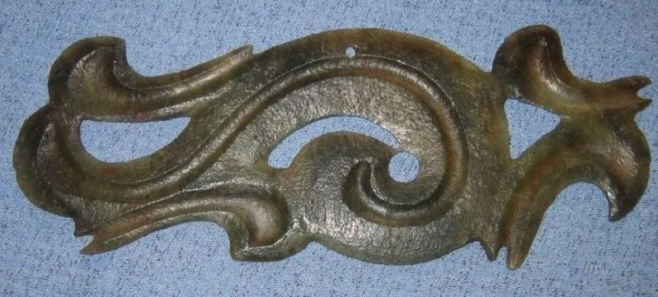 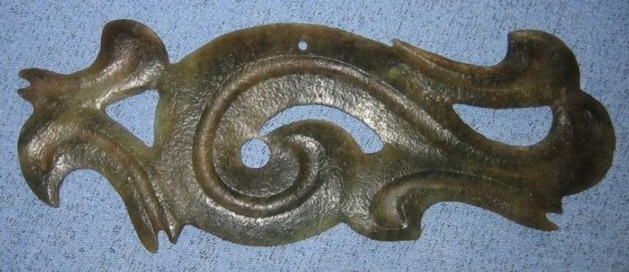

and reproduced in color plates in Liaoning archaeological institute, Niuheliang Hongshan wenhua yizhi yu yuqi jingcui (A short presentation of the Niuheliang archaeological site, Hongshan culture, and its jades), Beijing 1997, plates 11 - 15. A color plate reproducing one of the ornaments from Niuheliang is published in

width, 13.3 cm., height 5.0 cm., thickness 0.2cm., weight 25gm.

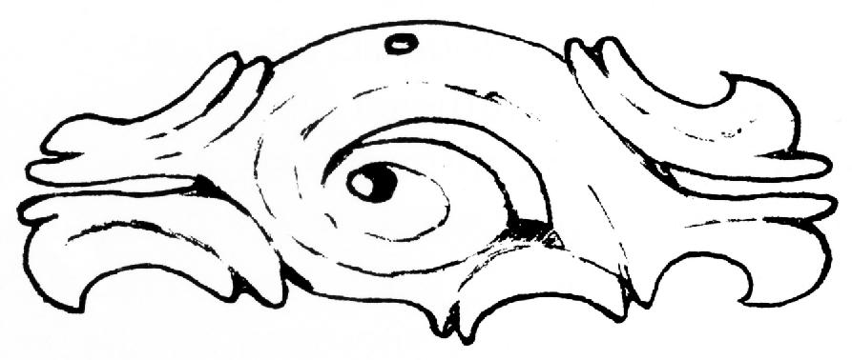

Drawing by Jenny So of hooked cloud scroll pendant from Dadianzi, Aohan Banner, Inner Mongolia, ca. 2000-1500 BCE, Jade, width 10 cm., in the Inner Mongolia Provincial Museum, Hohhot, after So 1993, Fig. 9b.

